Project plan: ESD Group 19

**Members**

Harry Marsh

Kamil Lukomski

Adam Gilley

Josef Anstey

Finley Horsley

Git repository: https://github.com/FinHorsley/ESD

REQUIREMENTS

|  |  |  |
| --- | --- | --- |
| Problem | Potential Solutions | Area |
| How to check the permission of different users | Filters - Chapter 13 of HF book | Permissions,  Users |
| What permission should each user type have? | Admin = everything  Doctors = all patient appointments  Nurses = all patient appointments  Patients = only their personal appointments | Permissions,  Users |
| User Registration | Need:   * Username * Password * Type (NHS/Private)?? * Address - use Google Maps API to get address from PostCode (dropdown)   > The signup operation should be authorised by admin if it is for a doctor or nurse user, otherwise can be done automatically. (from spec) | Users, Account, Registration |
| Forgot Password flow? (do we need this) |  | Users, Account |
| How to work out if the consultation should be charged as Private or NHS | When the patients sign up (creates an account) we would assign them either NHS or Private user type. When that patient then creates an appointment, we would use the patients userType as the type for that appointment.  If (Patient.UserType == NHS) {      Consultation.Type = .NHS  }  Else { Consultation.Type = Private } | Users,  Accounts |
| Calculating Cost of Consultation | **Either:**  1.Consultation time * cost  2. Separate service that calculates the cost of each consultation based on the consultation type. If the NHS changed their pricing, we could then adjust accordingly  3. Include the cost per hour of the consultation in the consultation model itself (as the price of the consultation should not change once the patient/NHS has been charged) | Consultations |
| How to create an invoice at the end of each consultation (surgery) | Do we need a separate service that is continuously looking at all the consultations in progress (in the database), and if it detects one that has ended, then send an invoice based on that consultation? | Consultations |
| Weekly Documents:   * Turnover * Private Payments * User Operation * Charges to NHS |  |  |
| How to calculate the turnovers for a given time range (day, month, year, etc.). Only admin should be able to do this |  | Accountancy (profits/turnover) |

**Sprint 1: Creation of project and setup of planning**

PLANNING

 During discussions, each task that is required to be looked into and developed is shown in the Task Delivery form.docx

Each individual will work on a field of the project. It would be wise to provide necessary insights to give confirmation if the objective for a task is met.

There can be a time management scheme used to give out how much time a person will spend before moving onto the next objective. It will be wise on some occasions where some areas will need more work depending on how important that area is and what the benefits are.

There will need to be necessary reviews on everything done before officially submitting it onto the blackboard.

SCHEDULING

 Weekly meeting set up for 4PM Every Thursday.

The purpose of these meetings is to update each other on the progress made for each of our assigned tasks visible in the Task Delivery form.docx.

Our medium of communication is a communication application called discord. We decided on this as we are all familiar with the software and it provides useful features such as file share and screen share.

DEMONSTRATION

Below is the demonstration of login system as well as registration

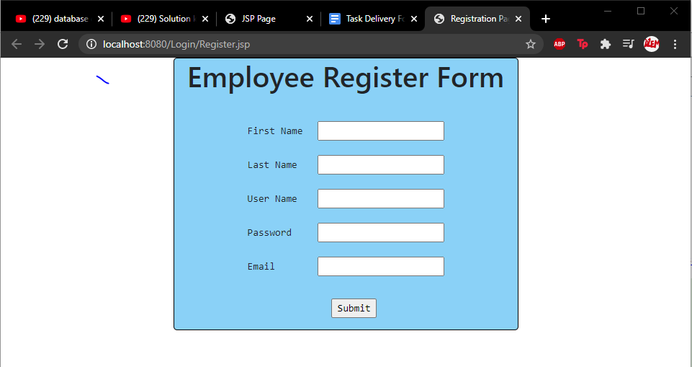

[Figure 1: Created a registration form so new users can register to the software. This data is then added to the users table in the database.]

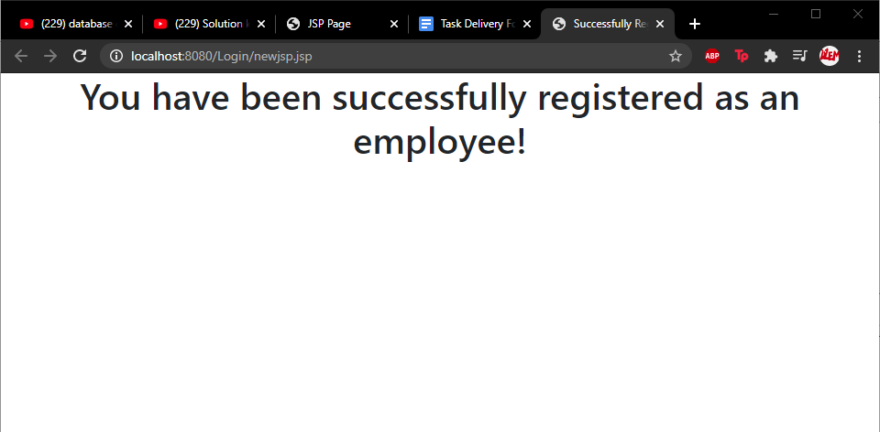

[Figure 2: Page displays that the user has successfully registered, and the data is added to the database.]

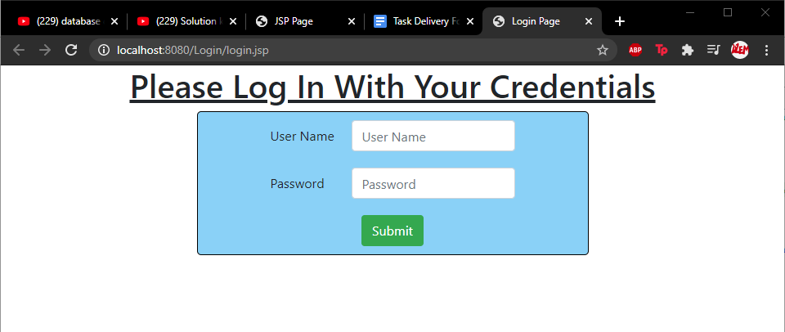

[Figure 3: The login screen for users to gain access to the system which is going to be developed in sprint 2.]

**Sprint 2: Backend Architecture.**

**Planning**

During sprint two we decided to have a weekly meeting on Thursday at 4pm where we discussed what we needed to do and what had been done. Below is a table describing what was discussed and the outcomes of those discussions.

|  |  |
| --- | --- |
| **Meeting 1 - 03/12/20** | |
| **Discussed** | **Outcomes** |
| Discussion of what work we needed to undertake for sprint 2 | Documentation requirements - presentation, backend architecture ,design Task delivery from (updated) and updated Project Plan.  Registration - register (admin/patient), Email ping to admin.  consultation - Attempt google API integration, consultation, turnover, invoice.  Prescriptions  - generate prescription after consultation, request re-prescription. |
| Delegation of work | Documentation requirements - Adam and Joseph  Registration - Harry  Consultation - Kamil, Fin and Harry  Prescriptions - Kamil, Fin and anyone who can help  We updated the task delivery document |
| Creation on Kanban chart in GitHub to better track project progression | Issues created-  Calculation of Consultation Fees  Invoice creation  Management Reports  Prescriptions  Google API integration  Employee Registration  Client registration |
| Creation of Burndown chart to decide pace for sprint and to chart progress | Decided on deadlines and effort required and how long certain tasks would take |

|  |  |
| --- | --- |
| **Meeting 2 - 10/12/20** | |
| **Discussed** | **Outcomes** |
| Discussed progress of requirements and work outlined in Meeting 1 | Client registration completed  Employee registration completed  Calculation of consultation fees completed  Google api integration ongoing  Management reports ongoing  Prescriptions ongoing  Google API presenting challenge and needs more group attention  Documentation production ongoing |
| Discussed burndown chart | We filled out the burndown chart and discussed our progress and whether we need to alter our efforts in certain tasks we were happy with our progression at that time |
| Discussed our presentation | We have decided to have a meeting again on the 16th December giving us as much time to complete the tasks as possible and decided who should present what parts  we also agreed to go over and complete documentation such as the burn down chart etc. on the 16th |

**Documentation**

During our conversations for the Sprint 2, there will be two group members selected to carry out the task of writing up and updating the various documentation requirements.

The documentation will involve detailed information about the overall nature of the project and would include things such as how processes, what are the elements, what are the results turned out to be, and what was improved to enhance the efficiency of the project.

There will be instances where it will have to read through what the description of the NetBeans project and to explain how certain elements of the entirety of the NetBeans project have been improved.

**Presentation**

Another field of this will be the creation of a presentation that will detail section by section briefly on the structures and characteristics of the project.

There will clearly be images that represent the structure of code that was used in the NetBeans project that enabled such success to be achieved when constructing the project first-hand.

**Demonstration**

Refer to presentation

**Task delivery form**

The first task we had to do is create a task delivery form to organize our sprint. We had a meeting about the requirements and decided what tasks we needed to complete. We decided there were 9 tasks we had to complete for this sprint and have divided up the task between our group members as shown. We decided Adam and Joe should take on most of the documentation Harry would take on the front end and Kamil and fin would do the backend architecture.

|  |  |  |  |  |  |  |  |  |  |  |  |
| --- | --- | --- | --- | --- | --- | --- | --- | --- | --- | --- | --- |
|  | **Tasks​** | | | | | | | | | |  |
| **Group Members​** | **T1​** | **T2​** | **T3​** | **T4​** | **T5​** | **T6​** | **T7​** | **T8​** | **T9​** | **T10​** | **Signature​** |
| **Harry Marsh​** | **X​** | **​** | **X​** | **​** | **​** | **X​** | **X​** | **X​** | **​** | **​** | **Harry Marsh​** |
| **Kamil Lukomski​** | **​** | **​** | **​** | **X​** | **​** | **X​** | **X​** | **X​** | **​** | **​** | **Kamil Lukomski​** |
| **Adam Gilley​** | **X​** | **X​** | **​** | **​** | **X​** | **​** | **​** | **​** | **X​** | **​** | **Adam Gilley​** |
| **Finlay Horsley​** | **X​** | **​** | **​** | **X​** | **​** | **​** | **​** | **​** | **​** | **​** | **Finlay Horsley​** |
| **Josef Anstey​** | **​** | **X​** | **​** | **​** | **X​** | **​** | **​** | **​** | **X​** | **​** | **Josef Anstey​** |
| **Status of Completion (%)​** | **100​** | **100​** | **100​** | **100​** | **100​** | **100​** | **100​** | **100** | **100​** | **N/A​** | **​** |

List of Task: ​

T1 - GANTT Chart updated​

T2 - Project Plan Updated​

T3 - Front-end - user interface, forms​

T4 - Back-end - partial completion of coding​

T5 - Completion of architecture Design​

T6 - Update Admins JSP - for Managing bookings, users, system​

T7 - Update Client JSP – for viewing booking details​

T8 - Update Employee JSP – for viewing booking details​

T9 - Presentation

**Burndown Chart**

The burndown chart is a useful tool we used to manage project progression for this sprint; it follows a 5-day work week over the two weeks. To produce this chart first we decided how long each of the 9 tasks would take so we could use this data to plot a line on a graph showing us the average amount of project work we would have to do every two days to complete the sprint. We updated the burndown chart every other day with the amount of work we had done towards each task. This allowed us to plot another line alongside the projected one showing us the actual work done and if we were staying on track to complete the work in the projected time. 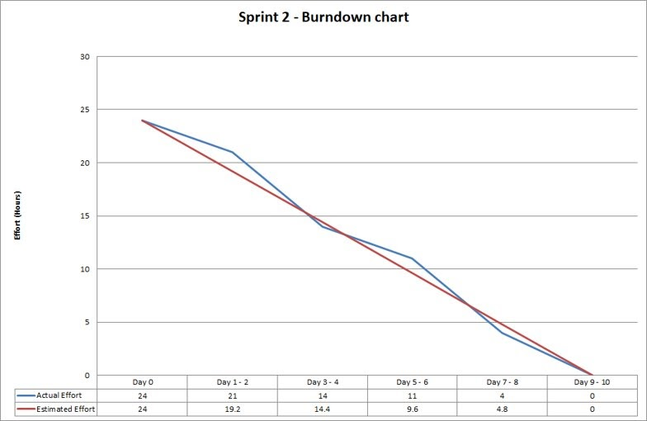

**Kanban Chart**

We used a Kanban chart that was integrated in and automated by GitHub so that we could all create issues and resolve them through the GitHub interface this acts as a to do list of all things we need to do this sprint and allows every group member to track the progress of others.

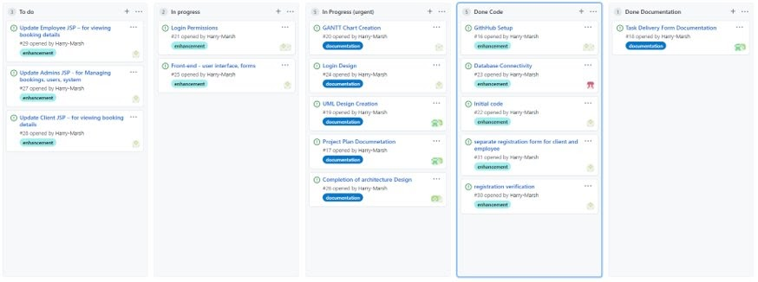

**GANTT Chart**

The GANTT chart is a useful tool for plotting the overall timing and progression of a project as you can clearly see what tasks are done and when and can look back at the overall progress of a project.

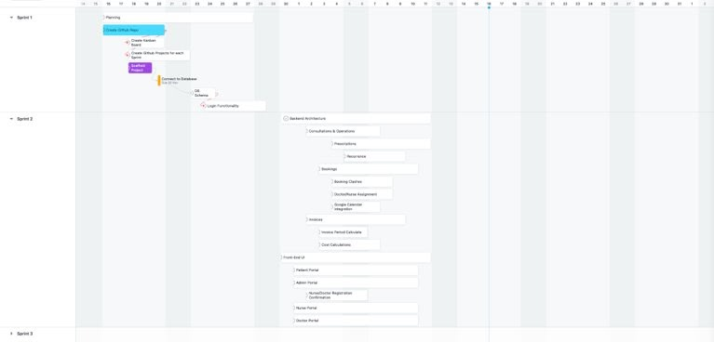

**Backend Architecture**

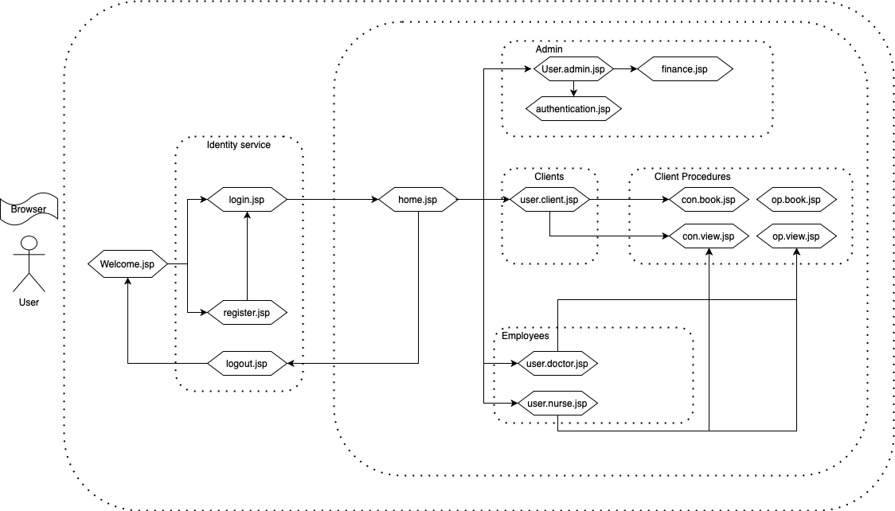

The Backend Architecture diagram shows how the different elements of the application fit together. By splitting the architecture into well-defined services, we were able to split the tasks down into smaller elements that could be implemented in parallel by multiple members of the team. Due to the nature of the servlets there is some overlap between the architecture of the front-end as well and the back end.